**Circles/Triangles**

**Set: 04.11.2011 Due: 09.11.2011**

LI: To tell the time to the hour and to the half hour.

In maths this week we have been working on telling the time. Your homework is to draw the hands on the clock to tell the time to the hour and to the half hour. You need to also write the time beneath it.

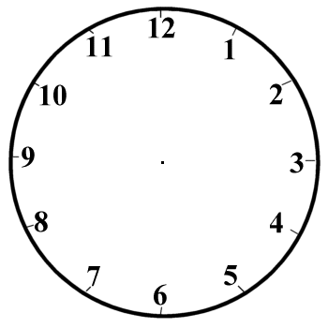





**Squares/Hexagons**

**Set: 04.11.2011 Due: 09.11.2011**

LI: To tell the time to the hour, half hour and quarter hour.

In maths this week we have been working on telling the time. Your homework is to create a time table of your day, like we did in class. You need to draw the hands on the clack face to show the hour, half hour and quarter to hour. Underneath you also have to write in the time.

