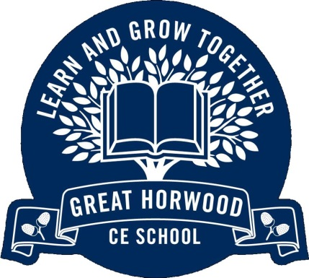

**Useful Information**

P.E. kit is needed in school every day. Our usual days for P.E. are Tuesday and Wednesday.

Homework is given out on a Friday and must be returned by the following Wednesday.

Please make sure your child reads every day with an adult and practises multiplication tables and weekly spellings.

Weekly spellings are available on the school website homepage.

Children may bring a bottle of water to school. Children may also bring a healthy snack of fresh or dried fruit to eat at break time.

Please ensure that **all** personal property is named.

Great Horwood

Church of England Combined School

**Conkers: Year 1/2**

Curriculum Overview

SpringTerm 2018

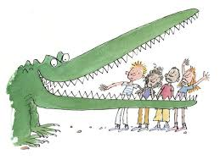

Fantastic Mr Dahl

**English**

We begin by learning the text of The Enormous Crocodile and through this story, creating alternative endings. We will also be exploring poetry through Roald Dahl’s rhymes and poems. Our grammar focus will be punctuation when writing questions, statements and commands and ensuring that our writing makes sense by reading it through very carefully.

***How can I support my child?***

Please read regularly with your child at home. Encourage your child to use punctuation whilst reading to support their understanding of the text. Please encourage your child to learn their spellings each week.

**Mathematics**

In maths this half term we will be covering; number and place value, addition and subtraction, money, properties of shape, multiplication and division. Our lessons will incorporate mental maths and how to use our mathematical knowledge to solve practical problems.

***How can I support my child?***

Count regularly with your child in multiples of ones, twos, fives and tens depending on their ability. Please help your child to learn the time, this is often the most tricky part of maths to master and can take a while (no pun intended!)

Year 1: o’clock, half past, quarter past and quarter to. Year 2: To the nearest 5 minutes.

**PSHE**

In PSHE this half term, we will be learning about what happens when we grow and what keeps us safe. This will include road safety, internet safety and stranger danger.

**Religious Education**

Our key question for the first half term is: Does everyone celebrate the New Year? Here we will be looking at the Christian and Jewish festivals that are celebrated in New Year. After half term, we will be exploring how important Easter is for the Church.

**Phonics**

As phonics plays a very important rule in Key Stage One, we will be practising our letters and sounds regularly every day and as part of a daily differentiated session. Year 1 will be preparing for the Phonics Screening Test in May.

**British Values**

We will explore British values in many different aspects of our learning. We will be learning about other cultures through RE and PSHE and how to respect these differences. We will exploring what being British means through our topic of Significant British Monarchs.

**Computing**

We will be learning about E-Safety which links to our PSHE and also simple programming.

**Curriculum Theme**

**(Geography, History, Art, Design and Technology and Music)**

This term our topic is significant British monarchs. We will be looking at the current Queen’s life as Britain’s longest reigning monarch and we will be taking this opportunity to learn about her family in the run up to Prince Harry’s wedding. We will also explore other famous Monarchs such as Queen Victoria, Henry VIII and Queen Elizabeth I (not necessarily in that order).

**Christian Values**

**(Love, perseverance, respect)**

Our key values this half term are Perseverance and Endurance, then followed by Perseverance and Friendship.

**Physical Education**

In PE this term we will be learning the skills of indoor athletics and dance and after half term; gymnastics and football.

**Science**

We are exploring the uses of everyday materials, where the children will be carrying out some simple tests to explore the best material for specific purposes. We will also be developing our scientific vocabulary when describing the properties of materials.