Homework
Set: 24.02.2012 Due in: 29.02.2012
In English we have been looking at the nonsense poems of Edward Lear. For your homework this week make up an imaginary animal of your own. Think of a name for it, draw a picture of your animal and then write a description of it. Remember to think of and try to include;
- what it looks like
- what it likes to eat
- where it lives
- how it talks
- how it moves
- WOW words in your description.

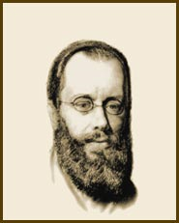
Edward Lear

